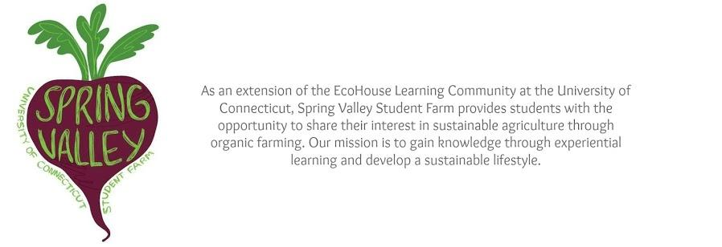

**Spring Valley Student Farm**

**Paid Summer Farmer**

**May – August 2025**

Welcome to the paid summer farmer fact sheet! Please review the information below before completing your application and reach out to Farm Manager [Jessica.larkin-wells@uconn.edu](mailto:Jessica.larkin-wells@uconn.edu) with any questions.

**About Spring Valley Student Farm**

Spring Valley Student Farm (SVSF) was created in spring 2010. SVSF provides students the opportunity to live and work together in a vibrant community focused on the common goal of healthy local food production. Students gain practical knowledge and regenerative farming skills through experiential learning. The farm is located 4.5 miles from the center of the UConn Storrs campus at 104 Spring Manor Road, Mansfield, CT, 06268. Spring Valley Student Farm is operated by Dining Services and exists as a collaborative venture with Residential Life and First Year Programs.

**Spring Valley Student Farm Mission:**

Spring Valley Student Farm (SVSF) provides an opportunity for UConn students and the greater community to join together to learn about environmentally, socially and economically ethical regenerative food production through hands-on experience. The Farm allows students to gain practical knowledge and skills through experiential learning while simultaneously modeling a closed loop food model. All produce grown at SVSF is served to students by Dining Services or sold at our on-campus Farm Fresh Market. Spring Valley Student Farm aims to be a place where students, faculty, staff, and Storrs-Mansfield community members can come together to learn about the connections between land, food, and people.

**Spring Valley Student Farm Goals**:

* Serve as a vanguard for the local, organic food movement on the UConn campus by encouraging students, faculty, and staff to consider the environmental, social and economic impacts of the foods they consume daily.
* Model efficient, effective regenerative organic farming techniques that yield healthy productive soil, increased farm biodiversity and hundreds of varieties of high-quality vegetables, fruits, herbs, and flowers.
* Encourage imaginative, innovative, and creative thinking to achieve more sustainable lifestyles and solutions.
* Host workshops, seminars, tours, and volunteer workdays for the campus community, local residents, and local schools.

**Paid Summer Farmer Program Overview:**

Paid summer farmers are core members of Spring Valley Student Farm, working alongside the farm manager and community of resident student farmers to grow produce for Dining Services. Since SVSF is an educational farm, the production team is invited to learn and question at every stage of the season, from planting to harvest. Through the diversity of the working group there is ample opportunity to learn from each other and from the land. Student farmers will learn sustainable, organic, and no-till growing practices for small-scale diversified vegetable production, including crop rotation, cover cropping, weed and pest management, composting, and soil building.

We want Spring Valley Student Farm to be a supportive and inclusive space for all who participate. Everyone who comes to the farm is expected to engage with other humans, species and the land with respect. As stewards and ambassadors of the farm, the student farmers also support SVSF as a living, welcoming laboratory where everyone may come to learn and grow.

**Summer Student Farmer Benefits:**

The Summer Student Farmer position is supported by University of Connecticut’s Department of Dining Services. This classification is a seasonal, part time, end dated, non-state position. This position provides the student farmer with a bi-weekly wage of $16.35/hr.

**Summer Student Farmer Responsibilities:**

The hourly paid SVSF Summer Student Farmer will be part of a food production team. Farmers are committed to working 20 hours per week from Monday, May 12 through Friday, August 22, 2025. Weekly hours are somewhat flexible, and applicants may request more or fewer than 20 hours per week. The weekly schedule is structured around production needs and community events, with a general schedule of two four-hour shifts offered daily (8:00am-noon and 2:00-6:00pm) Monday through Friday. Each student farmer plays an integral role throughout the growing season. Unpaid time off is permitted up to a maximum of two weeks total, to be arranged at least two weeks in advance of the requested time.

**Daily duties** will include but not be limited to: planting crops in fields and greenhouses, weeding, watering, beekeeping, and following standard operating procedures for produce harvesting, washing, packing, delivering and record keeping. Farmers may choose to lead farm tours for many ages and participate in the on-campus Farm Fresh Market. All student farmers are expected to attend Farm Meeting every week on Monday nights from 6:00-8:30pm.

The Spring Valley community agrees on the following **Community Values:**

* Community: We value a strong, healthy community where members can collaborate, resolve conflict, and learn from one another. We regard the health of our community as fundamental to our sustainability goals and inseparable from the success of the farm.
* Compassion: We practice compassion for ourselves, others, and the earth.
* Curiosity and Learning: We approach our farm community with curiosity. We practice experiential learning with a balance of action and reflection. We recognize that the best way to understand different perspectives is to ask and listen.
* Inclusion: We recognize that diversity is integral to the resilience of every human and ecological community. We strive to challenge inequities and create a “safer space” for people of all identities.
* Sustainability: We recognize our responsibility as an educational farm to practice agriculture that is both environmentally and socially ethical, to “take care of the land as if our lives, both material and spiritual, depended on it.” (Robin Wall Kimmerer).
* Action: We act not only to learn but also to transform our food system. We farm to feed our community and to equip ourselves with the skills necessary for food sovereignty.

**Summer Student Farmer Qualifications:**

This position is open to undergraduate and graduate students of the University of Connecticut who are currently enrolled full time for the fall 2025 semester or enrolled in a summer class. Candidates should be able to perform the following laborious tasks: bending, squatting, kneeling, and standing for significant periods of time, lifting and carrying up to 40 lbs, using long-handled tools such as rakes, shovels, and hoes, and working in direct sun as well as rain, in all temperatures experienced in CT from May- August. We strive to create an inclusive workplace and welcome candidates who utilize assistive technology, adaptive equipment, ergonomic tools, and/or perform labor tasks with modifications.

The summer student farmer needs a curious mind, a sense of humor in the face of adversity, and a proven positive work ethic. Students work in both independent and collaborative situations and should be prepared to meet challenges working solo and in a diverse group of peers. This position is intended to be educational, so previous growing experience is not required. Previous volunteering at Spring Valley Student Farm is considered during the selection process.

**Transportation:**

SVSF is located 4.5 miles away from the center of campus at 104 Spring Manor Road in Mansfield. There is no University or public transportation provided between the farm and the main Storrs campus. Students without their own car must be prepared to meet transportation challenges with creativity and determination. Many SVSF students carpool or ride their bicycles.

**Additional Optional Housing Information:**

The paid summer student farmer is encouraged but not required to live at the farm. All SVSF residents contribute **10 hours per week** toward running the farm, in exchange for a discounted housing cost of approximately $320/month. See the Summer Resident Farmer fact sheet (on the Housing page of the SVSF website) for more information.

**Questions?**

We encourage you to seek more information about the farm on our website or Instagram page @springvalleystudentfarm. You can also reach out to us individually:

* Student supervisor Jensen O’Meara via email at aeo22002@uconn.edu or by phone at 725-465-4012
* Farm Manager Jessica Larkin-Wells via email at [Jessica.Larkin-Wells@uconn.edu](mailto:Jessica.Larkin-Wells@uconn.edu) or by phone at 203-215-9345.

Please use phone numbers respectfully by contacting us during regular working hours: Monday through Friday, 7am-5pm.

**How to Apply:** Please submit the SVSF General Application, found on the Summer Employment tab of the SVSF website: <https://dining.uconn.edu/spring-valley-farm/summer-employment/>. Applications will be reviewed on a rolling basis. We look forward to hearing from you soon!